Przemysław Kordos, PhD., Hellenic Studies, Faculty of „Artes Liberales”, Univ. of Warsaw

Objects in traditional Greek Dance - Methodological Adventures

The present text was written within the Harmonia project “Objects in traditional Modern Greek dance”, which is generously sponsored by the Polish Ministry of Science and Higher Education (project no.: 2013/08/M/HS2/00447).

1. The beginnings

The idea to research previously untouched issue of object in dance came from Dr. Aliks Raftis. We managed to put it to a successful grant proposal and since October 2013 the project is „on the loose”, run by Hellenic Studies at the University of Warsaw and by the Greek Dances Theatre „Dora Stratou”. The team, led by Dr. Alkis Raftis and me, consists of dancers and researchers from the Theatre as well as of various Polish specialists: we have among us an orientalist, a choreologist, a classical philologist, an ethnographer and a musicologist. We stay in contact meeting sometimes in Athens, sometimes in Warsaw. As it is still too early to present some project conclusions - they would be still uncooked - we came across an idea to familiarize you with our methodological quest. As there is no unified methodology helpful in approaching objects in dance - OiD (especially in „traditional Greek dance”: TGD) it is to us to create first in promptu and later the final proposition of such approach with its taxonomy and system of relation. It is also up to us to name the important factors that should be taken into consideration while describing objects in dance and dances that make use of objects.
We wrote in the project: Though there is no unified approach to objects in dance, several aspects of the problem have been already thought over and described. And so we dispose of description of object-oriented sword dances (S. D. Corrsin), kerchief dances (Z. Friedhaber) or spoon dances (B. Henkel). In search for inspiration we are to move on to the “theatre props” theories, as stated for example by J. K. Curry or A. Sofer. Finally a promising approach is that of puppet masters who broaden their search and starting animating common objects as they were puppets (A. Walny).

2. Establishing the goal

Of course our project is by no means theoretical. It will result in two distinct outcomes: a web-based database of OiD and a synthetical Polish-English monography, co-authored by all project members that will serve as a companion to the database, will present its methodology and will provide a variety of interpretations and issues to pursue further.
The first “alpha-version” of the database will be ready - for testing - in early 2016, while the publications is scheduled for December 2016, at the project's conclusion.

3. Juggling clasifications

The initially established division of TGD units into laikoi („city folklore”) and dimotikoi („village folklore”) seems to be well justified as far as the presence of objects is concerned. Dances laikoi are few: chasapiko (with its quick version called chasapo-serviko), zeibekiko, karsimalas, tsifteteli to name the most popular ones, while dimotikoi are countless in comparison. Laikoi base more on improvisation, are independent of the region and probably younger in origin. The are also widely spread in other Balkan countries as well as - to some extent - in the Near East. Dimotikoi are much more localized and the genesis of some of them is arguably ancient.
As for the presence of objects, it is the domain of the dimotikoi dances - certain, already identified dances are „built” around objects - the object presence is an indispensable part of dance. On the other hand laikoi dances do not necessarily use objects. Their presence is not necessary and limited. Their type is to so extent arbitrary. Their functions (see below) are minor: mostly decorative. They could be regarded as accessories, in the sense of dispensable additions used mainly to adorn.
And so we come across a first advanced classification, looking for a function (or functions) a given object has in dance. The functions are as follows:
- ceremonial: the object is the centre of the dance, which sanctifies the object, as in the mattress dance; a sub-function would be here a dance which serves to exhibit the object - as in the Cypriot wedding dance with banknotes (ploumisma);
- symbolic: conveying meaning beyond the object;
- confirming manliness: the object is the means by which a dancer (male) proves its skill and gives performance demanding a lot of practising and courage (dances with sickle, glasses placed on head);
- theatrical: the object serves a prop - in pitsak-oin dance dances pretend to fight using knives; a sub-function here would be a situation where a dance is perform within a specifically constructed staging;
- technical: the object facilitates the dance: it helps in performing figures (as in michanikos), holding one another's hand in a procession-style dance (such a role is played eg. by kerchiefs held but consecutive members of a procession: kerchief both connect and separate the dance participants) a special type of this function (subfunction) is when the object creates music/rhythm (dance with spoons - koutalia);
- decorative: obviously secondary function - the presence of the object makes the dance prettier, as in the custom of throwing carnation head over the chasapiko/tsfteteli dancers.
This division is not and can not be disjunctive, as often objects fulfil various functions at once. They could be summarized in a infography:

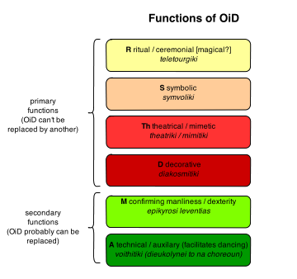
Functions could be primary, where an object is not subject to replacement and secondary, when one could think of another object having the same function in the same dance.
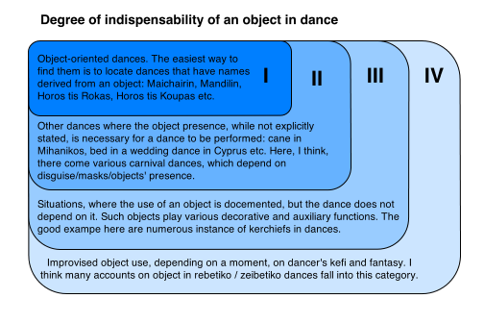
Another method of classification, given us by Mr Stergios Theocharidis is the degree of object indispensability in a given object-oriented dance. It goes as follows:

Other methods to order the material we gather include: situations most vulnerable for an object to appear (circumstantial presence), like wedding celebrations; geographic distribution - whether there is the geographically similar group of dances using objects more extensively than others (preliminary survey points at Cyprus); „transfer of meaning”: whether the cultural / symbolic meaning of an object is acquired through dance or is it the dance that gathers additional dimension through the use of an objects.
Especially this last proposition contains some valuable clues, for it touches the relation between the object and the dance. It seems that in normal circumstances it is the object that accompanies the dance, forming its element in the similar way the steps take shape with the music and rhythm. But there are situations where it is the object that is in the centre of attention with dance in objectified form. A good example is a 1919 postcard that I have recently included in our database. The postcard depicts women in traditional attire of Attica region. They pose to the photograph while dancing, objectifying their attire (playing here a decorative role).
The taxonomies mentioned above assign an object to one specific category/classification, not taking under consideration multiple ways of use for certain things. There is a way to solve this inconvenience employing a method that would also further formalize the object differentiation.
We could create a simple matrix of bipolar features - in a fashion of structuralism - and then apply the matrix to every object stating whether a specific feature is shared by this object (value 1), not shared (value 0) or does not apply (value NA). Such attribution draws from the experience of social sciences that develop a fieldwork procedure called coding that would allow easier application of numeric methods. As we are dealing with several hundreds of distinct objects it might be advisable to:

- describe them as thoroughly and uniformly as possible,
- seek help in quantitative methods in order to find correlations and trends not discernible intuitively.

Such bipolar features would be for example as follows:

1. The object is public / private (used by many people vs. used by one person)
2. The object is used by everyone regardless of gender / is used solely by men or women
3. (If so, the object is used by men/women)
4. The object is manufactured by a professional / home-made.
5. The object is / is not edible.
6. The object is / is not decorative.
7. The object has / has not decorative sub-genre (version).

4. Generic classification
But, it proved the simplest, most intuitive method would be most easily accepted by all the project members (who are not only multinational, but multidisciplined). As we are not abandoning other forms of classification, we decided it would be most advisable to divide the objects “generically”, according to what they are in their “out-of-dance” life.

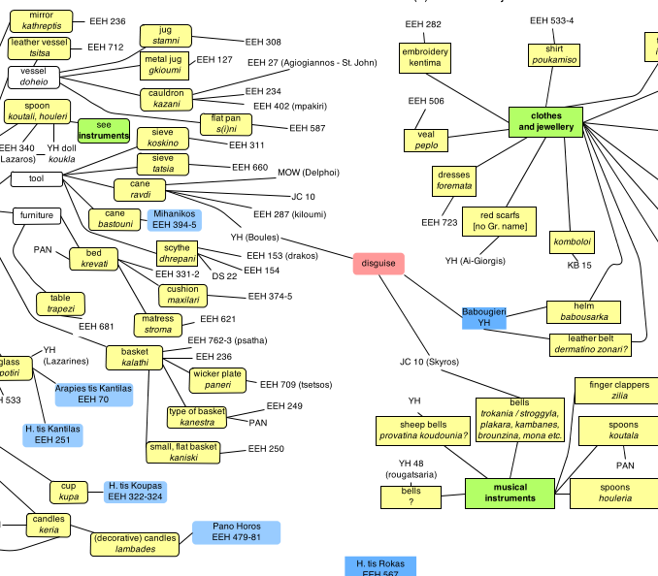
And some we came with the master-classification, in which the objects are divided into several groups:

- household objects
- clothing and jewellery
- musical instruments
- food
- animate objects
- weapons
- others (unclassified)

Most given groups are divided into sub- or even group, eg. household objects differentiate into tools, furnitures, vessels etc. We are also struggling to classify any “other” (unclassified) object putting it into some recognized category.
One additional remark - there is a special object among all of them, an object used most in many various dances, an object occurring in every second object-in-dance situation. That object is the kerchief, so versatile and multifuntional it has to receive a special treatment in our endeavours. We have some far identified no less than 20 dances involving kerchiefs. Their way of use, symbolism ad shapes are unlike under objects', which are as a general rule used only in a one or two specific and similar situations.
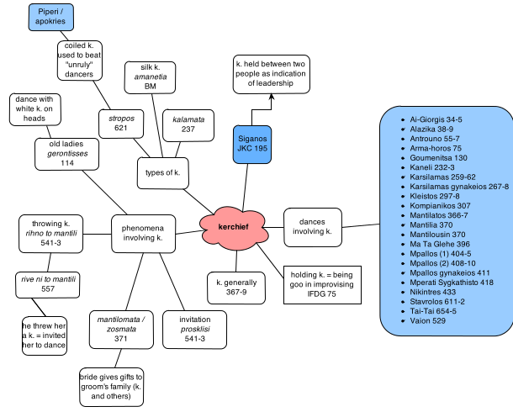

5. Defining borders
We have also separated two other uncommon sets of objects. The one set is connected to carnivals that we decided to analyse geographically. Many masquerades have their costumes composed of non-clothing garments and they are significant especially in using masks (is mask an object in our sense?)
Another situation is connected with money - paying and giving gifts to musicians and dancers (coins, banknotes and many other objects are involved).
Such situations may be treated as liminal, ie. the situations that are at the fringes of our interest. They are however remarkably numerous. There are many doubts on what to included and what not in our research. Some of the examples quoted below come from the original text of our project and include:

- dances that are in facts performances - story-telling, quasi-theatrical dance, e.g. Zalongo dance;
- dances that mimic the use of an object (without the actual presence of an object itself);
- dancing somebody (and not with somebody) - objectivisation of a person;
- dances in the Karaghiozis theatre - objects (puppets) that dance themselves - subjectivisation of an object;
- can scenography (ie. stage installations) be treated as a set of objects in dance (eg. a fire in middle, while dancers dance around it)?
- how to treat attire (parts of the attire) and instruments - are the objects in dance? If so than to what degree?

All these questions are especially valuable as the define borders of our interest and will all be (or already has been) addressed during our endavours.

5. Designing data
When we took under consideration a maximum amount of issues mentioned above, we came across a model for the data structure. Our database has two types of records. One of them is an abstract and idealized object that represents a type and is organized into a multi-forking graph according to the generic classification of objects. Any knot of the graph and especially this furthest branches are linked to a so-called testimony, ie. the manifestation of object in dance as seen through source data: a text, an image, a film. The source is quoted (and - if necessary - translated to English), tagged and heavily commented. Such features as place of occurrence, occasion (eg. wedding), specific use of object, as well as function(s) and indispensability degree are stated.
The point is to make to final database searchable on many levels - not only through a master-graph, but through regions, occasions, functions and so on.
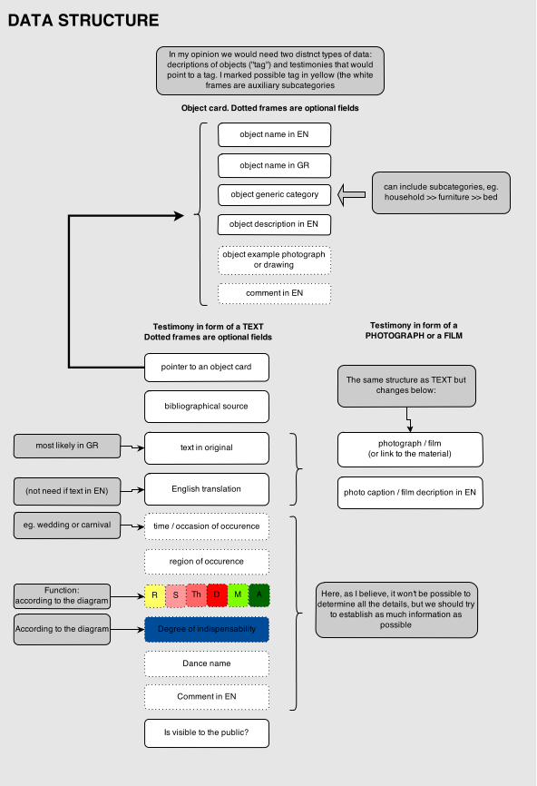
6. Choosing contexts

We do not leave behind important context. Soon a working version of diachronic text on object in Ancient Greek dance will be ready and by the end of the year we will cover the survey studies of important synchronic phenomena: object in Balkan and Jewish dance and object in Polish dance. These will be by far less detailed than our mains study - their goal will be to hint at possible connections and inspirations.

7. Work in progress

We are roughly half-way through the project My goal was to invite to all to the backstage of our workshop and to show you the ideas we have in tackling the goal in front of us, that is the question of objects in traditional Greek dance. Surely my presentation is cursory, moving on the very source of both phenomena and of our activities, but the final version of this draft paper will be much more detailed and will include not only indicative bibliography, but - hopefully - valuable remarks and feedback I crave to receive from the Congress participants.

