Class on Baroque Dance

Ingo Guenther, Barbara Zech-Guenther
Duration: 60 min.

Historical Dance: The Bourée-Family (La Bourée, La Gavotte, Le Rigaudon)

The Bourée-Family consists of three: two sisters and one brother. La Bourée is a very light-hearted person. Her movements are those of a fairy: lively, but not too fast, always smiling and happy. Her main step is the pas de bourée. Her sister, called La Gavotte, is somewhat slower in moving along (maybe she is not as slim), but dancing along with same steps as there are: pas de bourée, balancé, pas de sissonne and others. She is especially fond of the pas de gavotte, which basically consists of a hopping step, called contretemps. This is her favourite step that shows her loving mood best. The brother in the family, Le Rigaudon, is a typical French character and moving somewhat faster than his two sisters, but not much. He likes all the steps of his sisters but also has a step that shows his lively temperament best: pas de rigaudon. He throws his legs to the left and to right, ending up in first position while hopping three times (!). In our class we will have a look at the different characters of steps and work on a contredanse anglaise (ballroom dance) from Feuillet's collection of 1706. - When Louis XIV, Le Roy Soleil, founded the Académie de la Danse in Paris 1660 this meant to mark an important step in dance history: The beginning of ballet education (posture of the body, arm movements (porter-les-bras), foot positions (five at that time), changing dance levels (plié-relevé) .
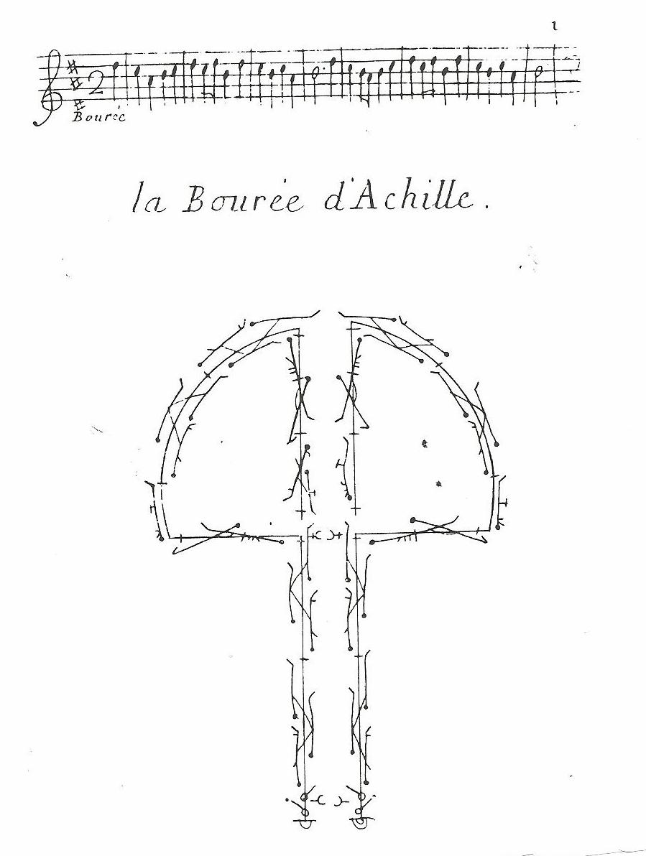
Baroque Dance Notation (Feuillet 1700)

